Assignment 1 – Part B

Creating and deploying Photo Album website onto a simple AWS infrastructure

Computer Science Department *Swinburne University   
Ho Chi Minh city, Vietnam*  
104775085@student.swin.edu.au

Student Name: Tong Duc Tu Tam

Student ID: 104775085

Date of Submission: 15/6/2024

***Abstract*—This document will present all my work in Assignment 1 – part B.**

Keywords—Cloud Computing, AWS Services.

- Assignment Checklist:

Infrastructure requirements:

1. VPC with 2 public and 2 private subnets

1.1 – Create VPC:

Figure 1: Create VPC with First, Last name and set the IPv4 CIDR block correspond to the requirement.

Figure 2: Successfully created VPC.

1.2 – Create subnets:

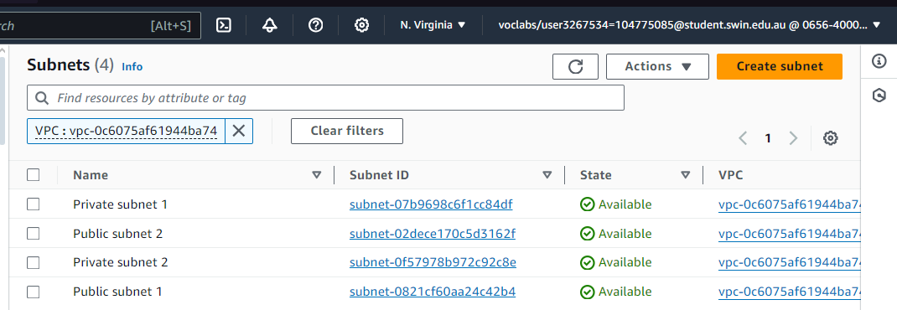

Figure 3: Created subnets.

Figure 4: Subnet availability zones

2. Correct Public and Private Routing tables with correct subnet associations

Figure 3: Create route tables.

Figure 4: Create igw.



Figure 5: Attach igw.

Figure 6: Associate subnets with correspond route tables.

3. Security groups properly configured and attached

Figure 7: TestInstance security Group configuration.

Figure 8: WebServer Security Group configuration.

Figure 9: DBServer Security Group configuration.

Figure 10: Configured security groups.

4. Network ACL properly configured and attached

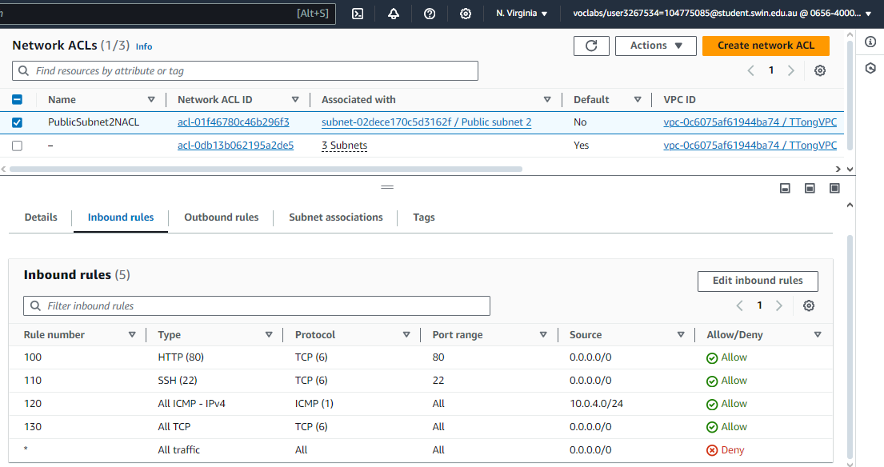

Figure 11: Set Network ACL inbound Rules.

Note: In the first time, when I specified three rules including: SSH, HTTP, ICMP, the connection was not success so I add another rule to allow all TCP protocol and everything works fine.

Figure 12: Set Network ACL outbound Rules.

Figure 13: Associate Network ACLs with correspond subnets.

5. Correct Web server and Test instances running in correct subnets

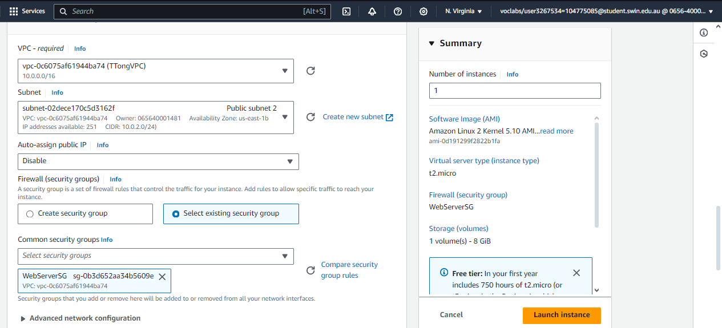

Figure 14: Create Web Server instance with the correspond subnet and security group.

Figure 15: Configure Test Instance

6. Database schema as specified

Figure 16: Config Database scheme as specified.

7. Database running in correct subnets

Figure 17: Set the subnet for database as specified.

Figure 18: Subnet group attached to database.

8. S3 objects publicly accessible, using proper access policy

Figure 19: Add bucket policy to make objects publicly accessible.

9. album.php page displayed from EC2 Web server

Figure 20: Display album.php on EC2 Web Server.

10. Photos loaded from S3 with matching metadata from RDS

Figure 21: Metadata from RDS database.

11. Provided URL is persistent (Elastic IP Association)

Figure 22: Associate Elastic IP to the Web instance.

12. Web server instance reachable from Test instance via ICMP

Figure 23: SSH into the Test Instance and ping the Bastion instance.